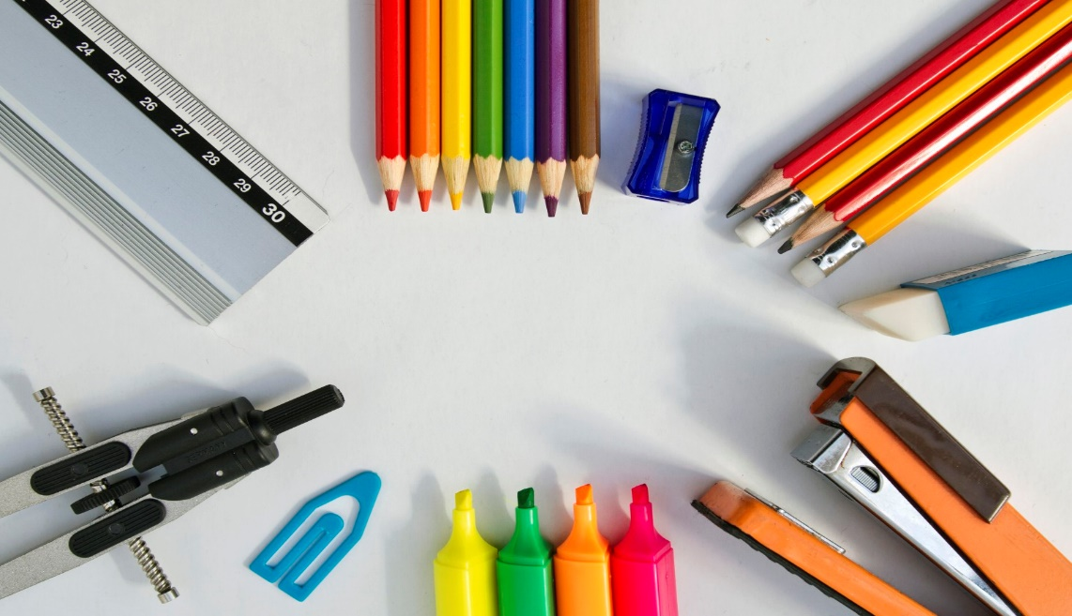

**GENERAL**

pencils & extra Lead

dry erase markERS – 4 or more

highlighters: yELLOW, BLUE, PINK, green, etc.

COLORED PENCILS OR MARKERS

LINED PAPER (WIDE RULED)

CLOROX WIPES & hand sanitizer (class donation)

2 BOXes OF KLEENEX

SCISSORS

EARBUDS/HEADPHONES for computer

Backpack with computer compartment or carry case

**\*no large zip-up binders please**

**Oasis 7th Grade**

**Supply List**

**SCIENCE**

1 Subject spiral Notebook (college ruled)

A 2 Pocket Folder for Science only

glue sticks

post-it notes

A HANDHELD pencil sharpener that catches shavings

**ELA**

1 COMPOSITION BOOK

1 subject Spiral notebook

INDEX CARDS

POST-IT notes

**SOCIAL STUDIES**

1-INCH, 3-RING BINDER (for SS only)

5 DIVIDERS

**MATH**

Scientific calculator (**casio fx-55 plus** or equivalent)

1½ INCH, 3-ring binder (for math only)

8 divider PAGES WITH TABS

sheet protectors (~25-30)

red pens

ruler